**Step 1: Create a Virtual Machine in Azure**

1. **Log in to the Azure Portal**:
   * Go to the [Azure Portal](https://portal.azure.com) and sign in with your account.
2. **Create a New Virtual Machine**:
   * In the Azure Portal, click on **"Create a resource"** from the left-hand menu.
3. **Configure the VM Basics**:
   * **Subscription**: Choose your subscription.
   * **Resource Group**: You can either create a new resource group or select an existing one.
   * **Virtual Machine Name**: Give your VM a name.
   * **Region**: Select **"West US"** from the dropdown menu.
   * **Availability Options**: Choose according to your needs (No infrastructure redundancy, Availability zone, etc.).
   * **Image**: Select **"Ubuntu"** from the list of available images (choose the specific version you need, e.g., Ubuntu 20.04 LTS).
   * **Size**: Choose the VM size based on your requirements.
4. **Configure Administrator Account**:
   * Choose the **Authentication type** (SSH public key or password). If using SSH, you'll need to generate an SSH key pair if you haven't already.
   * Enter the **Username** and **SSH public key** (if applicable).
5. **Configure Networking**:
   * Under the **Networking** tab, ensure a new virtual network and subnet are created or select an existing one.
   * Make sure to allow **Public IP** to connect to your VM.
6. **Open SSH Port**:
   * In the **Networking** section, add an inbound port rule to allow **SSH (port 22)** and **HTTPS (port 80)**
7. **Review + Create**:
   * Review your settings and click **"Create"** to provision the VM. This may take a few minutes.

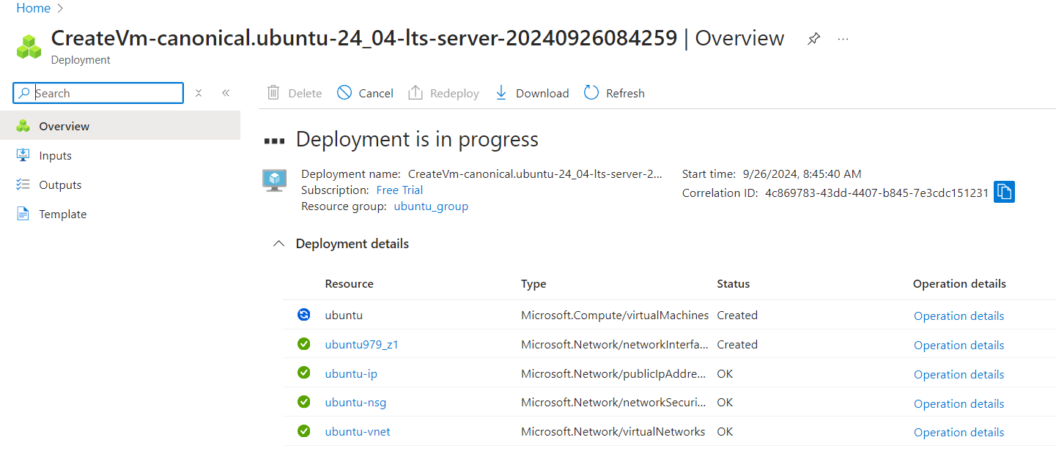

**Step 2: Connect to the Linux VM using Terminal**

1. **Get the Public IP Address**:
   * Once the VM is created, go to the **"Overview"** page of your VM in the Azure Portal.
   * Note the **Public IP address** of the VM.

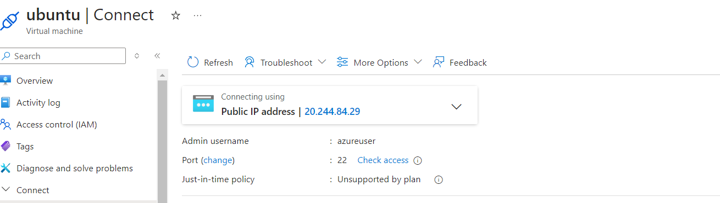

1. **Open Terminal**:
   * On your local machine, open a terminal (Linux, macOS, or Windows with WSL).
2. **Connect to the VM**:
   * Use the following command to connect via SSH:

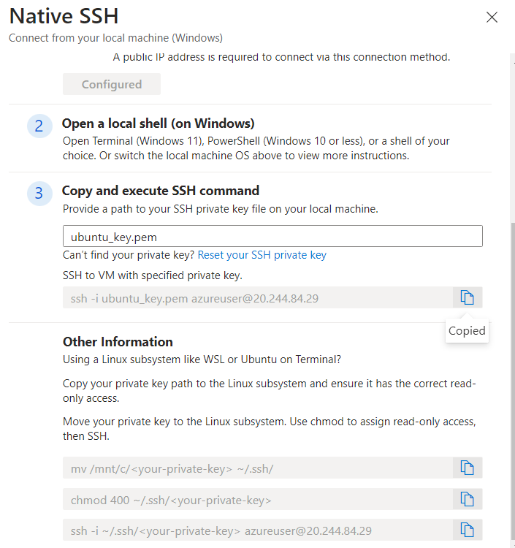

1. **Accept the SSH Key**:
   * The first time you connect, you'll be asked to confirm the authenticity of the host. Type **"yes"** and hit **Enter**.

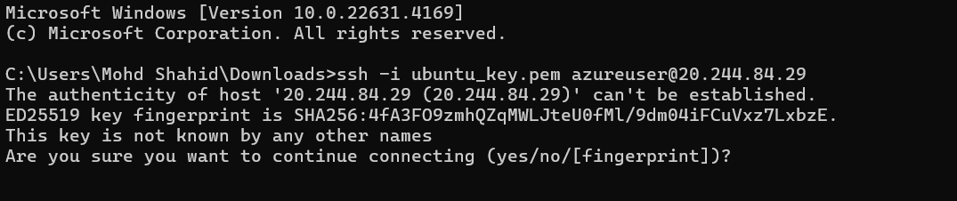

* + If you used a password for authentication, enter it when prompted.

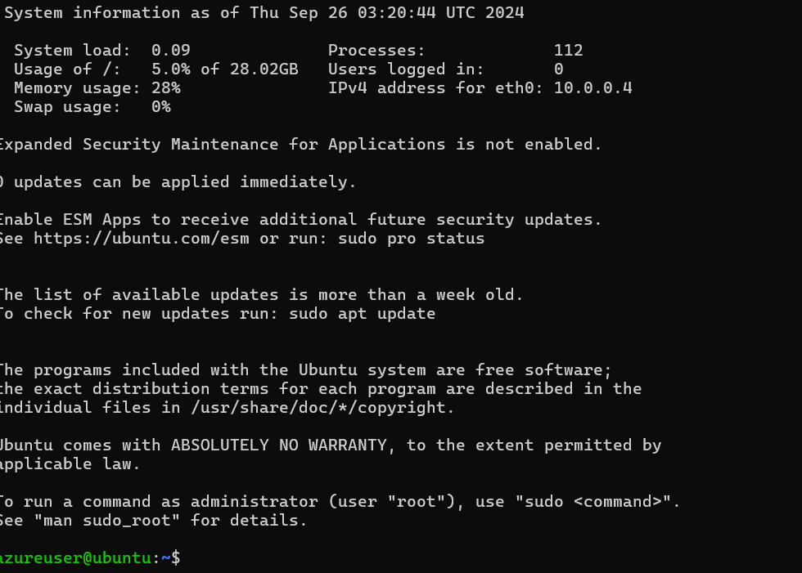.

**Step 2: Install Apache 2 Software**

1. **Update the Package Index**:
   * Run the following command to update the package index:

**sudo apt update**

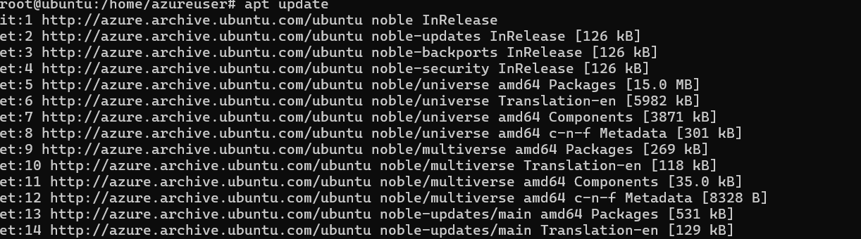

1. **Install Apache 2**:
   * Install the Apache 2 software with the following command:

**sudo apt install apache2 -y**

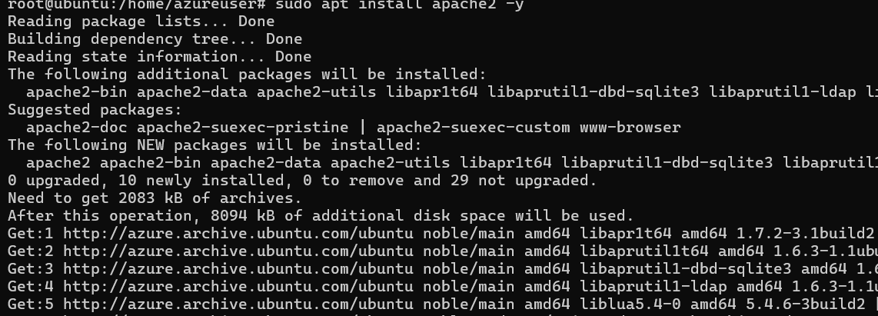

1. **Start Apache Service**:
   * Start the Apache service and enable it to start on boot:

**sudo systemctl start apache2**

**sudo systemctl enable apache2**

1. **Verify Apache Installation**:

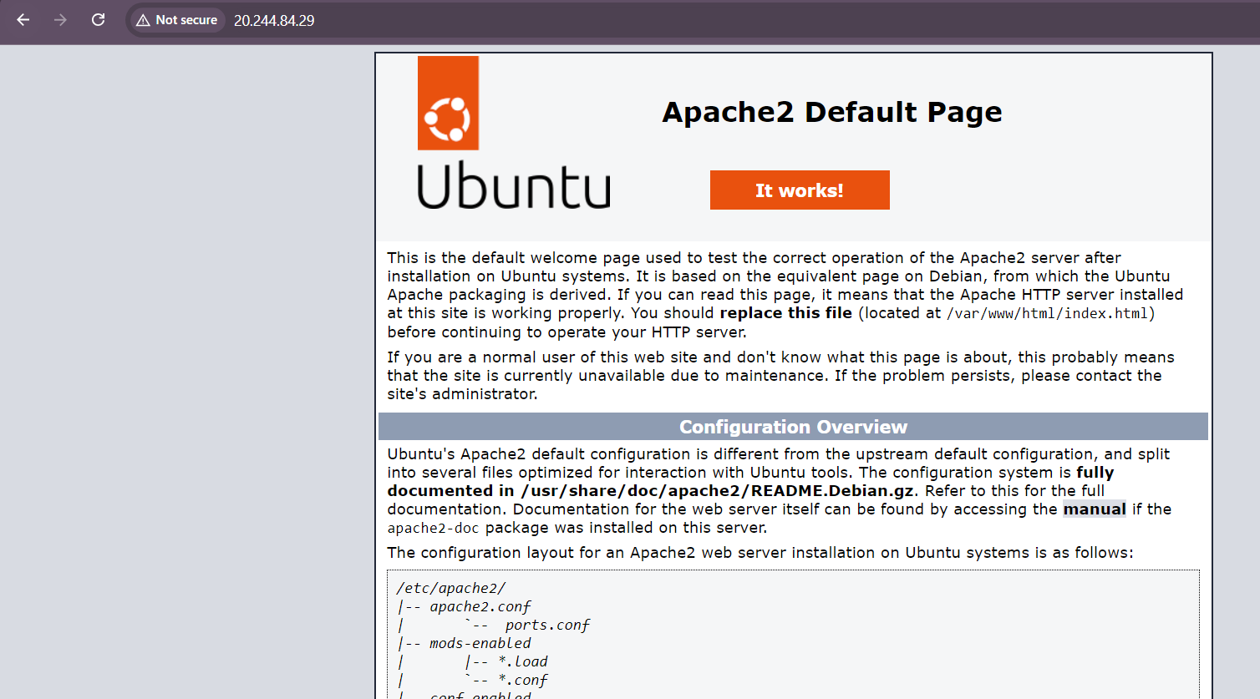

**Step 3: Create an Image Out of the VM**

* + Go to the Azure portal and select your VM from the list.
  + On the page for the VM, on the upper menu, select **Capture**.

